Matej Popovski
STAT 436

Prompt

Determine whether the following statements about ggplot2 are TRUE or FALSE. For at least one statement, provide an explanation based on the Penguins dataset demo.

- TRUE FALSE To use a custom color palette in a ggplot2 scatterplot, we can add a scale_color_manual layer.

TRUE - To use a custom color palette in a ggplot2 scatterplot, we can add a scale_color_manual layer.
Explanation: In ggplot2, you can define custom colors for specific groups in a scatterplot by using scale_color_manual(). For example, using the Penguins dataset:

ggplot(penguins, aes(x = bill_length_mm, y = bill_depth_mm, color = species)) +
geom_point() +
scale_color_manual(values = c("Adelie" = "red", "Chinstrap" = "blue", "Gentoo" = "green"))

- TRUE FALSE A geom_boxplot layer can be used to simultaneously visualize a continuous variable against many levels of a categorical variable.
TRUE - A geom_boxplot layer can be used to simultaneously visualize a continuous variable against many levels of a categorical variable.
Explanation: geom_boxplot is commonly used for this purpose. For instance, using the Penguins dataset to visualize flipper length (continuous) against species (categorical):
ggplot(penguins, aes(x = species, y = flipper_length_mm)) +
geom_boxplot()

- TRUE FALSE A plot like the one shown below can be made using a geom_area layer.
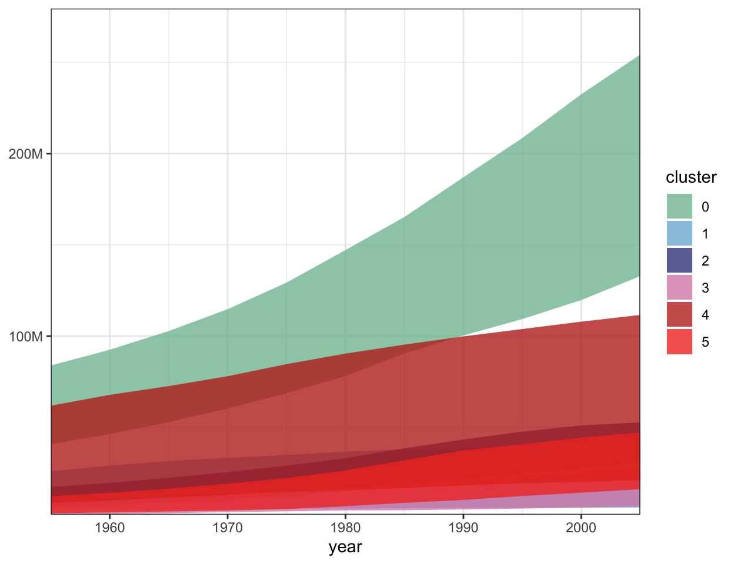
TRUE - A plot like the one shown can indeed be made using a geom_area() layer in ggplot2.

Explanation:
The geom_area() function in ggplot2 is specifically designed to create area charts, where the y-values are filled between the x-axis and a line representing the data. Stacking can be applied by mapping a categorical variable (such as cluster) to fill.

- TRUE FALSE The aes() function maps values stored in the columns of a dataset into properties of graphical marks.

TRUE
Explanation:
The aes() function in ggplot2 is used to map variables (columns) from a dataset to visual properties (aesthetics) of graphical marks, such as position, color, size, shape, etc. These mappings determine how the data is represented in the plot.

Responses

- TRUE - slide 18 b) TRUE - slide 16 c) TRUE - slide 11 d) TRUE - slides: all💀

- TRUE b) TRUE c) TRUE d) TRUE

- TRUE (prof changed colors for penguin species) b) TRUE c) TRUE d) TRUE

TRUE b) TRUE c) TRUE d) TRUE - live lecture demo example, where the prof applied the bill_depth and bill_length across all layers of graphs on the figures (across geom_smooth, geom_point, etc.)

- TRUE b) TRUE c) TRUE d) TRUE: Using color to show a third property in the dataset

- TRUE b)TRUE c) TRUE d) TRUE

- TRUE b) TRUE c) TRUE d) TRUE

- True b) True c) True d) True

- True b) True c) True d) True

- True

- True b) True c) True d) True

- True b) True c) True d) True

- TRUE b) TRUE c) TRUE d) TRUE
For a if we are writing this ggplot(penguins, aes(x = bill_length_mm, y = bill_depth_mm, color = species)) + geom_point() + scale_color_manual(values = c("Adelie" = "blue", "Gentoo" = "red", "Chinstrap" = "green")). Here scale_color_manual() overrides the default palette and applies the custom colors for each penguin species.

- True b)TRUE c)True d(True

- True b) True c)True d)True

- TRUE b) TRUE c) TRUE d) TRUE

